GIT Department of Computer Engineering
CSE 222/505 - Spring 2020
Homework #1 Report

Harun ALBAYRAK
171044014

1-SYSTEM REQUIREMENTS
The software is developed on IntelliJ Idea platform and can be executed on this platform but since the software is Java-based, it can be executed on any system Java JDK 8 or more installed.

For IntelliJ Idea:
2 GB RAM minimum, 8 GB RAM recommended
3 GB hard disk space, SSD recommended
1024x768 minimum screen resolution

2-USE CASE DIAGRAMS
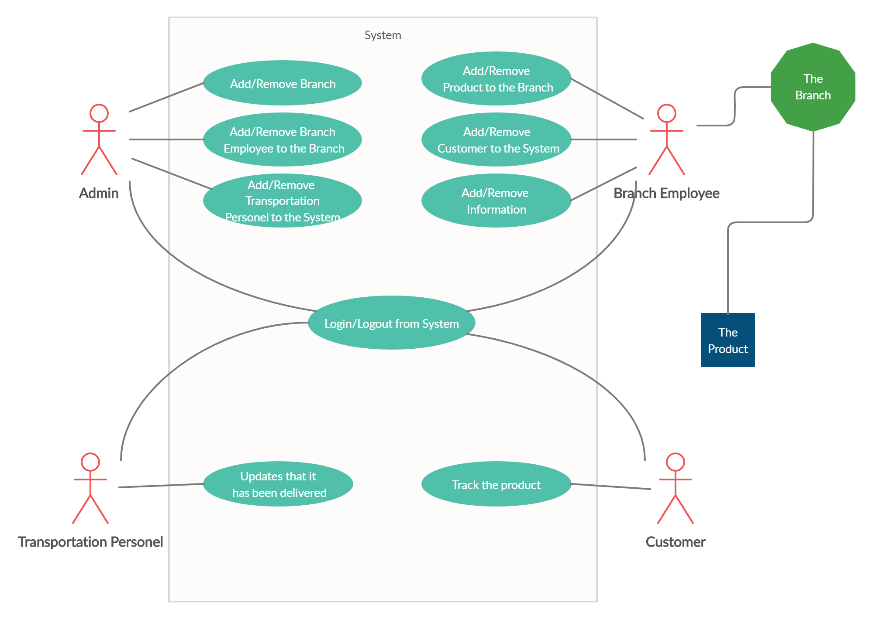
3-CLASS DIAGRAMS
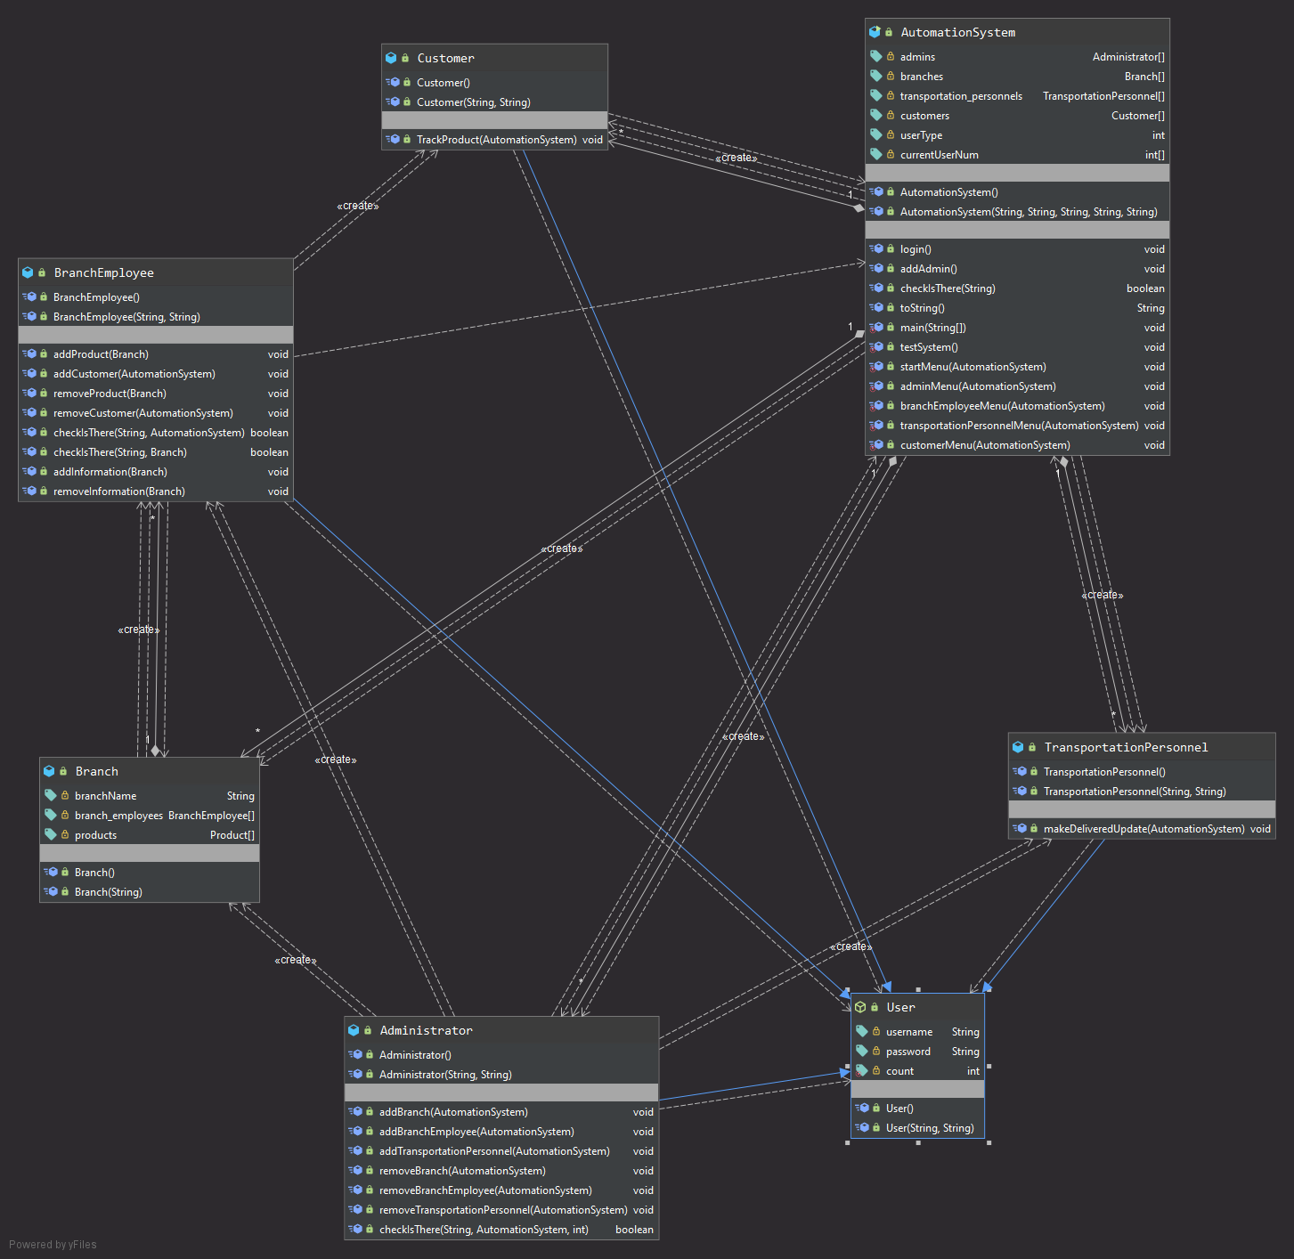

5-PROGRAM SOLUTION APPROACH
I tried to build a certain order to create a cargo automation system. The automation system includes Admins, Branches, Transportation Personnel and Customers. Branches include Branch members and Products.

In this system, administrators should have the authority to add and remove branches, add and remove transport personnel, add and remove branch employees

Branch employees should have the authority to add and remove products, add and remove customers, add and remove information.

Transport personnel should have the authority to update the delivery information when they deliver the product.

I also extended the Admin, Transportation Personnel and Branch Employee classes from the 'user' class.

The user class includes the user name and password fields. And other than that, they only have constructors.

When the system is opened, users can log in or log out.

In addition to the system, admin can be added. Also, I created the method of printing the system to see the system.

6-TEST CASES
Firstly,The system is created automatically.
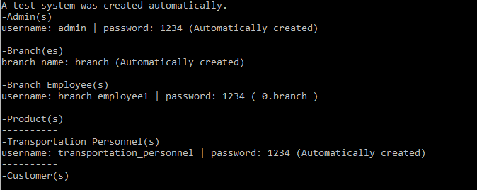

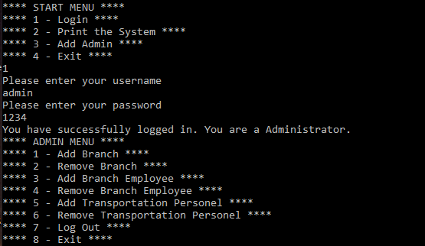
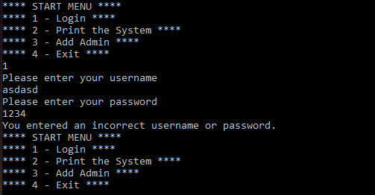
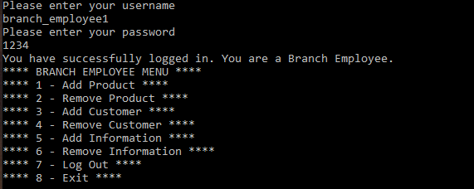
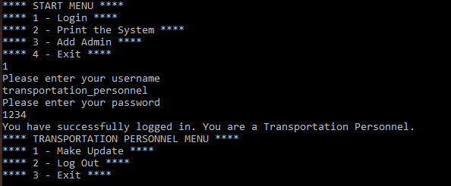
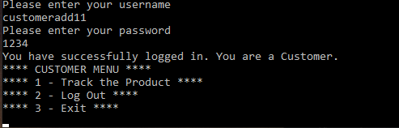
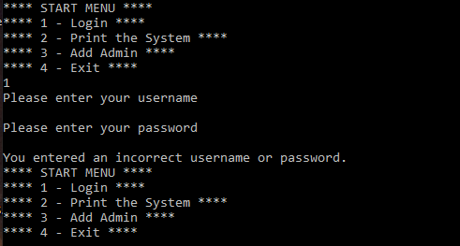

Test cases

7)RUNNING AND RESULTS
